**AM1802XP 1.8meter Inkjet printer with 2 XP600 Print head (the economic version)**

**USD: $3300~4300**

**Product Details**

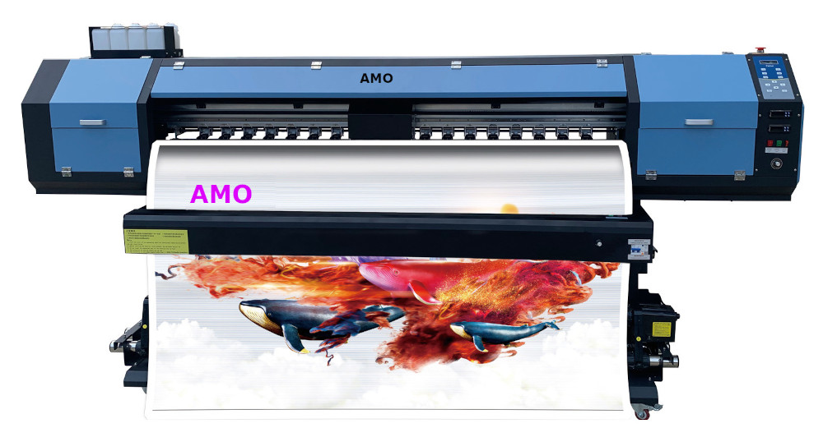Model Name:AM1802XP

Print Width: 1.8meters  
Maximum Media width: 1.8meter  
Print head： Epson XP600 print head  
Number of Print head：2 piece  
Resolution: 360 x 720 dpi  
Printing Speed: 4Pass Mode 22 square meters per Hour  
Printing Media: PP Paper, Photo Paper, Vinyl, Transfer Paper, Blue back paper etc.  
Color : CMYK  
Ink :Eco-Solvent ink, Sublimation Ink(or other water based ink)  
Ink Capacity : 1 Liter per Color  
Port of Connection to Computer : USB/NET  
Print head to Media distance: 2mm to 3 mm   
Printing Location system: Raster and Servo system  
Ink drying System: Fan and heater  
Motor and Driver system: Combined high precision motor and driver for Carriage and Step   
Printing System: Hoson ,the leader of printing system in China  
Ink Station: Aluminum high precision Print head Maintenance Station.  
Rip Software : Maintop, RIIN, Photoprint  
Photo format: JPG,TIFF,BMP,PDF  
Heating system: Automatic Temperature Control system equipment.  
Media supply system: Automatic Media roll-up system  
Maximum Media weight: 90kgs  
Power demand: 50/60HZ 220V AC  
Working Temperature: 20-25 CESUS   
Working Humidity: 40-70%  
Machine Size: L2,980mm X W750mm X H1250mm  
Net Weight:210 KGS  
Packing Size: L2,900mm X W600mm X H400mm   
Gross Weight: 250 KGS

(The real machine might be a little different to the printer showed in this catalog, especially some detail might be different)